VALOMENTA
SEN2022 WELLNESS APP ROJECT
Kaan Yalman 2104371,
Burak Demirci 2201292,
Nada Muhammed Mahmood Mahmood 2474548,
Marah Layth Hasan Hasan 2104511

- Requirements Analysis
a) User registration and login with security in mind
overview
The user registration and login module is a critical component to ensure the app’s usability and safeguard user information. This module provides secure entry points for users to access their wellness dashboards and update health indicators while preventing unauthorized access. It emphasizes ease of use, compliance with data protection laws, and robust security measures to counter evolving cyber threats.

Detailed Features
User Registration
• Data Input: Users must provide essential information, such as:
◦ Full name
◦ Email address or mobile phone number (as a unique identifier)
◦ Password (with strength indicators and validation rules)
◦ Optional demographic information (e.g., age, gender) for personalized app experiences.
• Validation:
◦ Input validation ensures all required fields are completed accurately.
◦ Emails are validated for proper formatting (e.g., username@example.com).
◦ Phone numbers are checked for valid formats, including country codes.
• Duplicate Checks: Prevent duplicate accounts by verifying email addresses or phone numbers against the database.
• Confirmation Mechanisms:
◦ Upon registration, users receive a confirmation link (email) or an OTP (SMS).
◦ The account remains inactive until the confirmation step is completed, ensuring validity and preventing bots.
User Login
• Credential Authentication:
◦ Authenticate using email/phone and password combinations stored securely in a hashed and salted format (e.g., using bcrypt).
• Session Management:
◦ Securely manage user sessions with encrypted cookies or JSON Web Tokens (JWTs).
◦ Sessions should automatically expire after a configurable duration of inactivity (e.g., 15 minutes).
• Device Recognition: ◦ Provide optional device recognition to reduce friction for returning users while still maintaining security.
Password Recovery
• Secure Workflow:
◦ Users can request a password reset using their registered email/phone.
◦ A one-time, time-limited link or OTP is sent for verification.
• Identity Verification:
◦ Additional identity checks, such as verifying a previously set security question, can enhance security.
Account Management
• Updating Credentials:
◦ Users should be able to update their email, phone number, or password.
◦ Trigger security alerts whenever sensitive information changes.
• Account Deletion:
◦ Provide users with a clear and secure process to delete their accounts if desired, including a grace period for recovery.
Functional Requirements
These requirements define the system’s functionality, outlining the behaviors and processes needed for user registration and login.
1. Registration
• Provide a dedicated registration page for users to enter their details.
• Validate user-provided information in real time to minimize errors.
• Automatically send a confirmation link via email or an OTP via SMS immediately after registration.
2. Login
• Authenticate users by verifying their credentials in real time and grant access upon successful verification.
• Detect and block repeated failed login attempts using rate-limiting techniques.
• Offer biometric login options, such as fingerprint or facial recognition, for supported devices.
3. Forgot Password
• Generate a secure, one-time password reset link or OTP for users who need to recover access.
• Enable users to set a new password securely after completing identity verification.
4. Account Security
• Monitor and log suspicious activities, such as logins from new devices or locations, and alert users. • Implement multi-factor authentication (MFA) for enhanced security during login.
5. Access Control
• Restrict access so users can only view and modify their own data.
• Define role-based access to functionalities (e.g., administrator vs. standard user) to ensure appropriate permissions.
Non-Functional Requirements
These requirements outline the app’s key qualities, focusing on reliability, security, scalability, and user experience.
- Security
• Data Encryption: Passwords must be securely encrypted using advanced hashing algorithms like bcrypt or Argon
• Secure Connections: All communications between the app and servers must use HTTPS with TLS 1.2 or newer.
• Threat Mitigation: Implement firewalls, intrusion detection systems, and safeguards against brute-force attacks.
- Performance
• Ensure that the registration and login processes are complete within 2 seconds under standard conditions.
• The system should handle peak traffic, accommodating up to 10,000 simultaneous registrations or login attempts.
- Scalability
• Architect the app for horizontal scalability to support a growing user base.
• Utilize scalable cloud solutions, such as AWS or Azure, to manage databases and ensure efficient load balancing.
- Usability
• Provide an intuitive interface with clear error feedback to guide users, such as explanations for weak passwords.
• Incorporate accessibility features, including screen reader compatibility for users with visual impairments.
- Compliance
• Ensure compliance with global data protection standards like GDPR and HIPAA to protect user privacy and sensitive information.
4. Detailed Workflows
User Registration Workflow
- The user navigates to the registration page and provides the required information.
- The system validates the inputs for accuracy and checks for duplicate accounts.
- A confirmation email or OTP is sent to the user for verification.
- Upon successful confirmation, the user’s account is activated and ready for use.
User Login Workflow
1. The user inputs their registered email or phone number along with the password.
2. The system authenticates the credentials and initiates a secure session upon success.
3.If multiple login attempts fail consecutively, the system temporarily locks the account to enhance security.
Password Recovery Workflow
- The user starts the password recovery process by entering their email or phone number.
- The system generates and sends a secure, time-sensitive reset link or OTP to the user.
- The user verifies their identity and sets a new password to regain access.
b) An intuitive way to set and track goals and daily activities
Functional Requirements
- Goal Setting:
  - Personalized Goal Setting:
    - Users can define their own goals for various metrics (steps, meditation time, sleep duration, heart rate, calorie intake, water consumption, etc.).
    - The app provides a variety of goal types to choose from, catering to different wellness aspects.
  - Goal Customization:
    - Users can set specific target values for their goals (e.g., 10,000 steps per day, 15 minutes of meditation).
    - Users can set the frequency of their goals (daily, weekly, monthly).
    - Users can set reminders for their goals.
  - Goal Selection:
    - The app offers predefined goal templates or suggestions based on common health recommendations or user data.
    - The app provides information about the benefits of achieving specific goals.
  - Goal Modification:
    - Users can easily edit or adjust their existing goals as needed.
    - The app tracks the history of goal modifications.
  - Goal Tracking Period:
    - Users can set the timeframe for their goals (daily, weekly, monthly).
    - The app provides options for recurring goals.
- Daily Activity Tracking:
  - Manual Entry:
    - Users can manually input their daily activity data (e.g., steps taken, sleep duration, heart rate).
    - The app provides clear instructions on how to manually enter data.
  - Data Integration (Future Consideration):
    - The app can potentially integrate with other devices or apps (e.g., fitness trackers, smartwatches, health platforms) to automatically collect activity data.
    - The app supports secure data transfer and integration with third-party devices and apps.
  - Activity Logging:
    - The app logs all recorded activity data with timestamps and location data (with user permission).
    - The app provides a calendar view for users to review their activity logs.
- Progress Tracking & Visualization:
  - Progress Display:
    - Users can view their progress towards their goals in a clear and understandable format (e.g., progress bars, charts, graphs).
    - The app provides different visualization options to cater to user preferences.
  - Real-time Tracking:
    - The app updates progress in real-time as users input or the app receives data.
    - The app provides haptic feedback for progress updates.
  - Historical Data Review:
    - Users can access historical data to review their progress over time.
    - The app provides filtering and sorting options for historical data.
  - Reporting/Summaries:
    - The app generates summaries of activity and goal achievements (e.g., daily, weekly, monthly summaries).
    - The app provides insights and analysis of user data to help users understand their progress and identify areas for improvement.
- Notifications/Reminders:
  - Goal Reminders:
    - The app sends reminders to users to encourage them to stay on track with their goals.
    - The app provides motivational messages and tips.
  - Progress Notifications:
    - The app notifies users when they achieve milestones or are close to reaching their goals.
    - The app provides celebratory messages and badges for achieving goals.
  - Customizable Notifications:
    - Users can customize notification settings (frequency, type, sound, vibration).
    - Users can choose to snooze or dismiss notifications.
Non-Functional Requirements
- Usability:
  - Intuitive Interface:
    - Goal setting and tracking should be easy and straightforward to use, even for users who are not tech-savvy.
    - The app provides clear instructions and tooltips.
  - Clear Visualizations:
    - Progress should be displayed in a visually appealing and easy-to-understand manner.
    - The app uses charts and graphs that are easy to interpret.
  - Simple Navigation:
    - Users should be able to easily navigate between different sections of the app related to goal setting and tracking.
    - The app has a clear and consistent navigation structure.
- Performance:
  - Fast Data Processing:
    - The app should quickly process and display activity data and progress updates.
    - The app uses efficient algorithms and data structures.
  - Efficient Data Storage:
    - The app should store activity data efficiently to minimize storage usage.
    - The app uses data compression techniques.
- Reliability:
  - Accurate Data Tracking:
    - The app should accurately track and record activity data.
    - The app uses reliable sensors and data sources.
  - Consistent Performance:
    - The app should perform consistently without errors or crashes.
    - The app undergoes rigorous testing and quality assurance.
- Security:
  - Data Privacy:
    - User activity data should be stored securely and protected from unauthorized access.
    - The app uses encryption and access control mechanisms.
  - Data Security:
    - The app complies with relevant data privacy regulations.
    - The app has a clear privacy policy.
- Accessibility:
  - Accessibility Considerations:
    - The app should be designed to be accessible to users with disabilities (e.g., screen reader compatibility, appropriate color contrast, alternative text for images).
    - The app follows accessibility guidelines and standards.

c) A reporting feature to view historical data on wellness goals and health metrics.

- The application must send a notification to the user when a goal is achieved.
  - The notification should be sent immediately after the goal is accomplished.
  - The notification should be easily understandable by the user and support multiple languages.
  - Notifications should be sent error-free to the network or server.
- The application must send a notification before the next day to alert the user if a daily goal is not met. This notification should indicate the remaining progress of the goal and include a motivational message to encourage the user to accomplish it before midnight.
  - The notification must be sent exactly between 20.00 and 23.59 based on the user’s time zone.
  - The limit for notification must not be more than 200 characters.
  - The notification should be easily understandable by the user and support multiple languages.
- The application must display the user’s activities for the previous 7 days on the main page. This should include metrics such as steps taken, traveled distance, burned calories, sleep duration, maximum and minimum heart rate during the day, etc.
  - This interface should be visible at the same time when the user opens the application. If is not possible it should not exceed 1.5 seconds.
  - The interface must be designed to handle large amounts of user data without performance issues.
  - If the user’s phone is in auto-rotate mode open the visuals in portrait mode but should also be turned to horizontal mode upon request. The visuals should be adaptable for various sizes of screens and resolutions.
  - The visuals should use charts, lists, and bars, and must be clearly readable and understandable by all kinds of users.
- The application must open the view of the monthly activity when the user clicks on the 7-day activity segment on the main page. The same visuals and health metrics also must be on this screen. This screen should also include a movement button between all available months.
  - This interface should be loaded within 1.5 seconds upon clicking the 7-day activity segment.
  - The interface must be designed to handle large amounts of user data without performance issues.
  - If the user’s phone is in auto-rotate mode open the visuals in portrait mode but should also be turned to horizontal mode upon request. The visuals should be adaptable for various sizes of screens and resolutions.
  - The visuals should use charts, lists, and bars, and must be clearly readable and understandable by all kinds of users.
  - The buttons for transition should be clearly visible and not be eye-straining for all users.
  - The transition between monthly records should be smooth. The requested monthly navigation should be seen by the user within 100 milliseconds.
- The user can generate a summary of all recorded activities with a button on the main page if it is needed. Upon generating the summary, a screen should open and show the summary afterward. This summary should include all-time progress, presented day by day, and should be in a downloadable PDF format.
  - This file should be generated in no more than 4 seconds.
  - The PDF file should not be more than 1 MB.
  - The PDF file should include all the health metric records and make it easily understandable by the user.
  - Before downloading the application should send a pop-up message and request the allowance from the user.
- The application should allow the users to compete or cooperate on a chosen goal within a specified period with friends. This feature should be accessible via a segment at the bottom of the main page. The system should also send notifications to the users when some progress is achieved.
  - The button for changing the page should be clearly visible and not be eye-straining for all users.
  - The transition between the main page and this page should be visible and not be eye-straining for all users.
  - The transition between pages should be smooth. The user should see the requested navigation within 100 milliseconds.
  - The page should be easy to navigate through and understand. The competitive/cooperative modes should be displayed in the middle of the page and should be easy to navigate, create, and manage the goals.
  - The modes should support up to 12 participants, including the main user who creates the group.
  - The period for accomplishing a goal should be chosen by all the users who participate, with the maximum length of the goal of 7 days.
  - The goal should be chosen by all the users who participate, and it can be scaled with the time limit. The goal can be selected within health metrics such as steps taken, traveled distance, burned calories, etc.
  - The page must handle multiple users simultaneously without delays. Therefore, the system must be capable of handling high user traffic.
  - The progress should use visuals such as charts, lists, and bars, and must be clearly readable and understandable by all kinds of users.
  - The modes should allow the users to view real-time progress without delays. The latency can be acceptable for up to 10 seconds to update the progress.
  - The notification for encouragement should be sent either when a milestone is achieved, or the goal itself is accomplished by the users.
  - The notification for warning should be sent either if the due date is less than one-fourth of the specified time limit or if there is no progression by the users more than one-fourth of the specified time limit.
  - The notification should be easily understandable by the user and support multiple languages.
  - Notifications should be sent error-free to the network or server.
- The user can see the comparison between the same day among weeks and the comparison between the days of the week within.
  - The visuals should use charts, lists, and bars, and must be clearly readable and understandable by all kinds of users.
- The application should allow the user to insert permanent information such as gender, blood type, disorders that need caution, etc. in the registration screen. If the user does not insert any of this data, later it should be accessible by a screen in the options screen.
  - The interface must be designed to handle large amounts of user data without performance issues.
  - The interface should be easily understandable by the user and support multiple languages.
- The application should allow the user to insert daily-basis information such as daily water consumption in glasses, stress level, meditation duration, etc. The application should not force the user to insert this information.
  - The interface must be designed to handle large amounts of user data without performance issues.
  - The interface should be easily understandable by the user and support multiple languages.
- The application should allow the women users to insert their menstruation day and remind the user within the application and with notifications when their estimated period is coming closer.
  - The interface must be designed to handle large amounts of user data without performance issues.
  - The interface should be easily understandable by the user and support multiple languages.
  - The notification should be easily understandable by the user and support multiple languages.
  - The notification must be sent within 4-5 days before the estimated date.

d) Notifications to keep users engaged and motivated
Functional Requirements
- Reminders:
Notifications are sent to remind the user to meet their goals for the day. The user will receive notifications about:
● StepGoals
● Workout Goals
● Waterintake goal
● Meditation time
The default notifications are:

‘Only 123 more steps to go!’ (To be replaced by steps left) OR ‘8k steps down, 2k more to go!’ (To be replaced by the user’s goals)

‘Ten more workout minutes to go!’ OR ‘You’re almost there! 🏋 ’

‘You have 8 more glasses to go for the day! 💧 ’ (To be replaced by glasses left.)

‘You haven’t meditated today!’ OR ‘Five mediation minutes left for the day!’ (To be replaced by minutes left)

The user will also get notified about their sleep. If they hit their sleep goals they will be congratulated and if they didn’t a notification will be sent informing them, with a sad face emoji, that they didn’t sleep well last night. Once they click on the notification, an article will be displayed on how they could improve their sleep.
The default notifications:

‘Congratulations, you hit your sleep goal last night!’

‘You didn’t hit your sleep goal last night :(‘

‘You didn’t hit your sleep goal last night 🙁 ’

The user can choose if they want emojis or text-based emojis.
The user will be able to customize the messages they want to receive in their notifications.
Upon extreme fluctuation of a user’s heart rate, they will be sent a notification notifying them and upon clicking on it, they will be presented with methods to increase or decrease their heartbeat.
The user could choose to receive notifications for some goals but no others.

- Notifications’ Timing:
The user could choose what time of the day their notifications are sent in. The user could also choose how frequently the notifications are sent- some users may like to be constantly reminded throughout the day while for others one or two reminders are sufficient.

The user could also choose to not receive notifications at all.
- Content and Interactivity:
The notifications should also require user interactivity to prevent oversight. Once a notification is sent, it should display two reply options: ‘I’m on it!’ or ‘Remind Me Later’. If the user has chosen to only receive two notifications throughout the day and they don’t interact with one of them, then a third notification should be sent and so on.
The user is free to turn this feature off.
- Progress:
Once a user completes a daily goal, they will be congratulated. And, if they complete a goal every day for a week they will be further congratulated at the end of the week.
The default notifications will be:

‘Congratulations, you hit your (insert goal) for the day!’
Congratulations, you hit your (insert goals) every day this week!’
The user is free to change the content of these texts.
If the user doesn’t interact with five notifications, then their usual notification schedule will be paused, and they will be sent a notification encouraging them to login. The notification will include motivational quotes.
The default notifications will be:
‘Small steps everyday lead to big changes. Start now!’
‘You’ve got this, let’s crush those wellness goals together!’
‘Don’t let yesterday define today. Start fresh now!’
‘The hardest part is starting. You’ve got this!’
The user is free to customize these.
Non-Functional Requirements:
1- Performance:
The notifications should be delivered on the clock. They will follow the local device’s time zone.
The system must be able to send fifty thousand notifications simultaneously.
Regarding the pool of default notifications’ content, no message will be duplicated until all the available content has been used.
2-Reliability:
If a notification is not delivered to the user, the delivery must be re-attempted three times. If it still doesn’t go through, then the app will report a problem to the programmers.
If not successfully delivered, and interacted upon by the user, notification will be duplicated.
3-Customizability:
The text customization of notifications must have an upper limit of 150 characters and a minimum of 50 characters.
4-Security:
The notification should not reveal sensitive data about the user. Such as their height, weight and other sensitive data submitted.
5-Battery Efficiency:
Notifications should be optimized to not drain the devices’ batteries.
6-Accessibility:
The notifications should be able to support voice over text for blind users and notifications’ text should have enlarging options for the visually impaired.
7-Integration:
The app shouldn’t bypass the system’s mode. If the device is in Do Not Disturb then the notifications will comply.

- Use Case Diagram

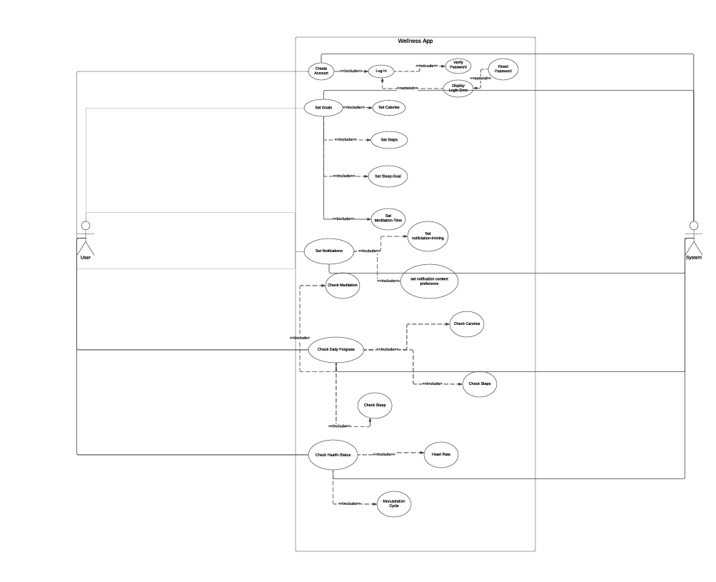

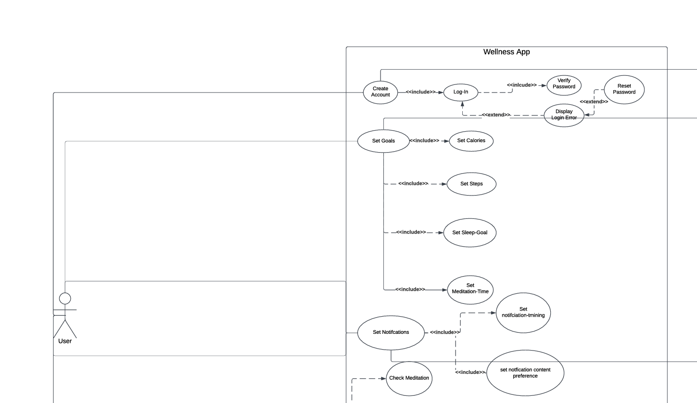

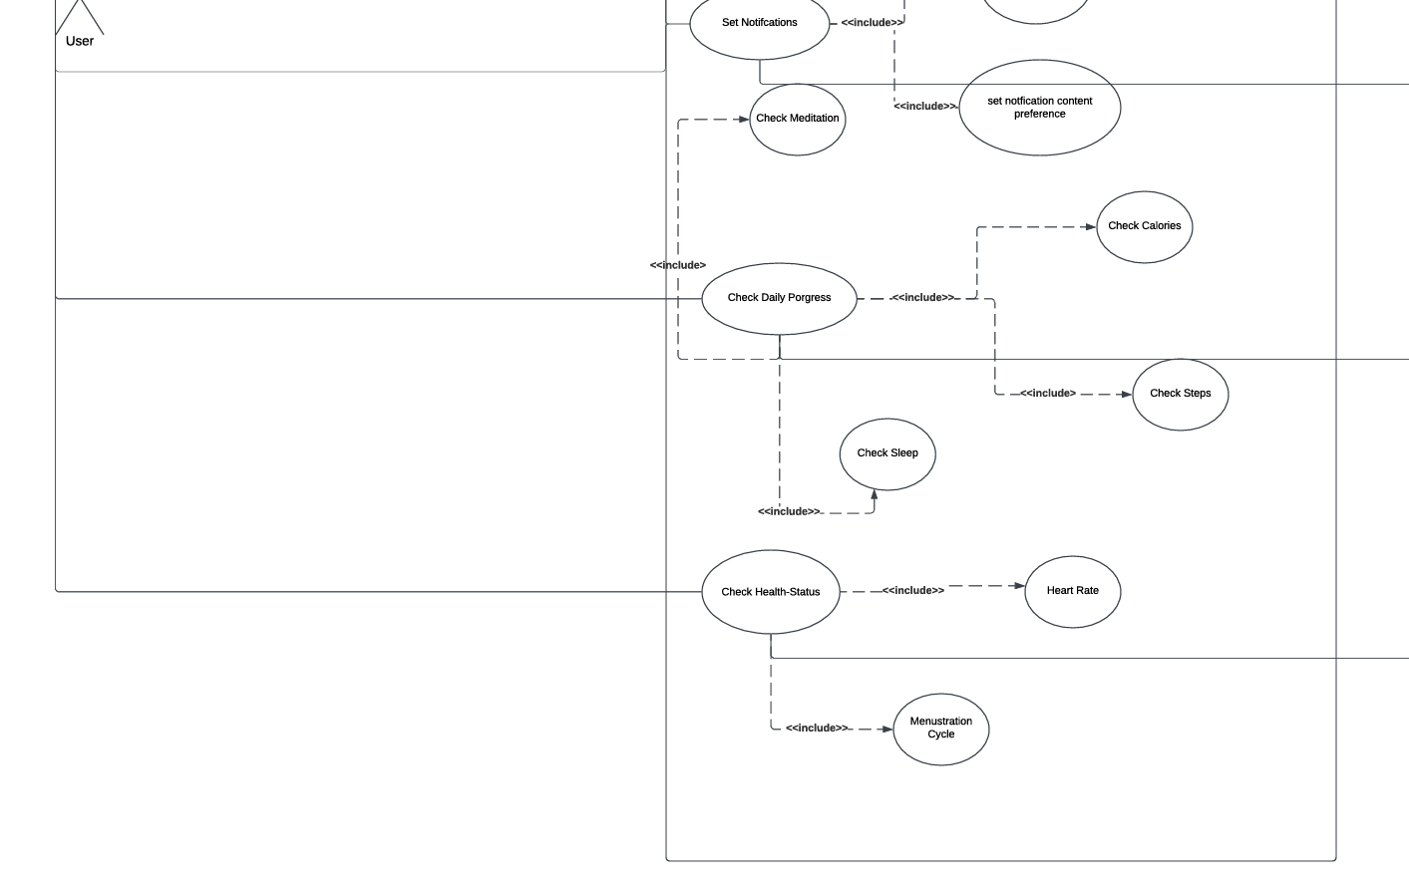

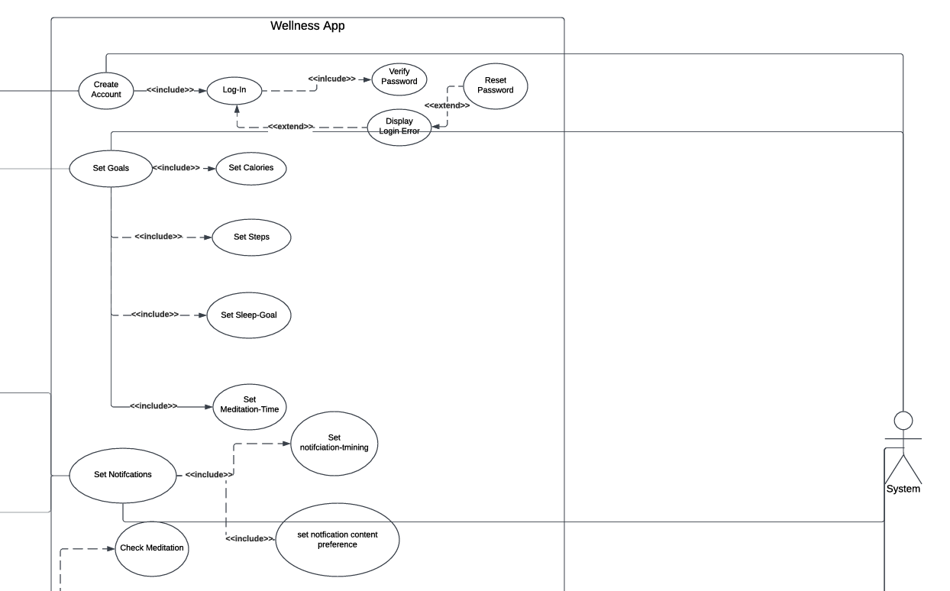

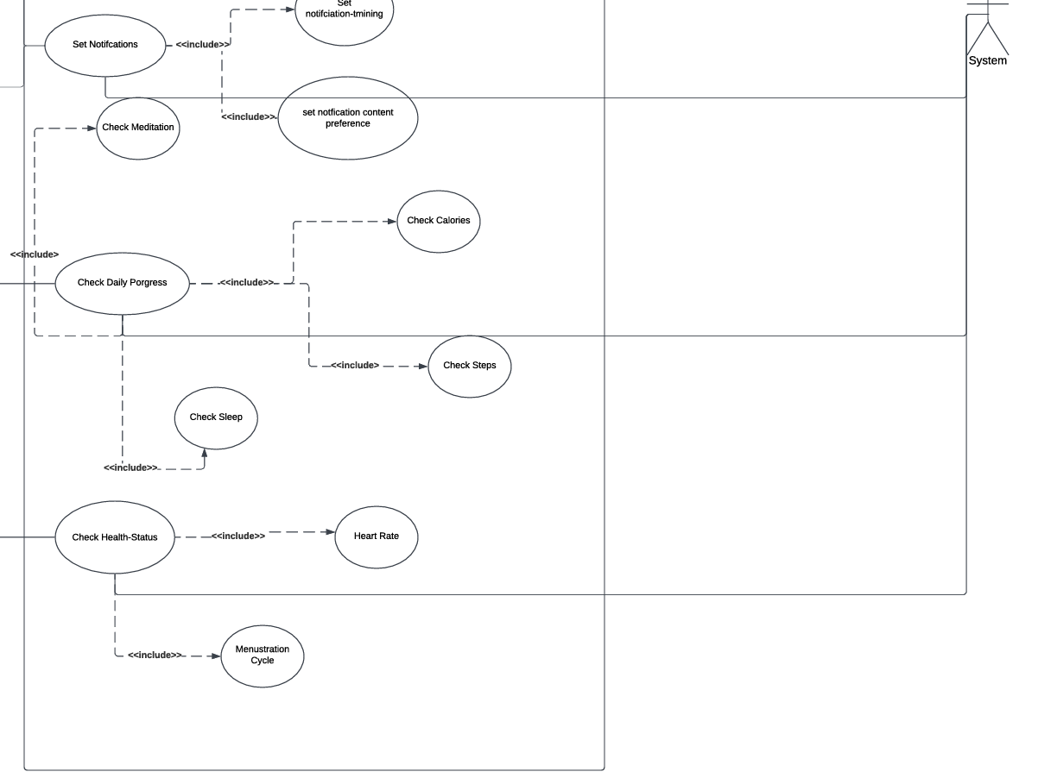

- Class Diagram

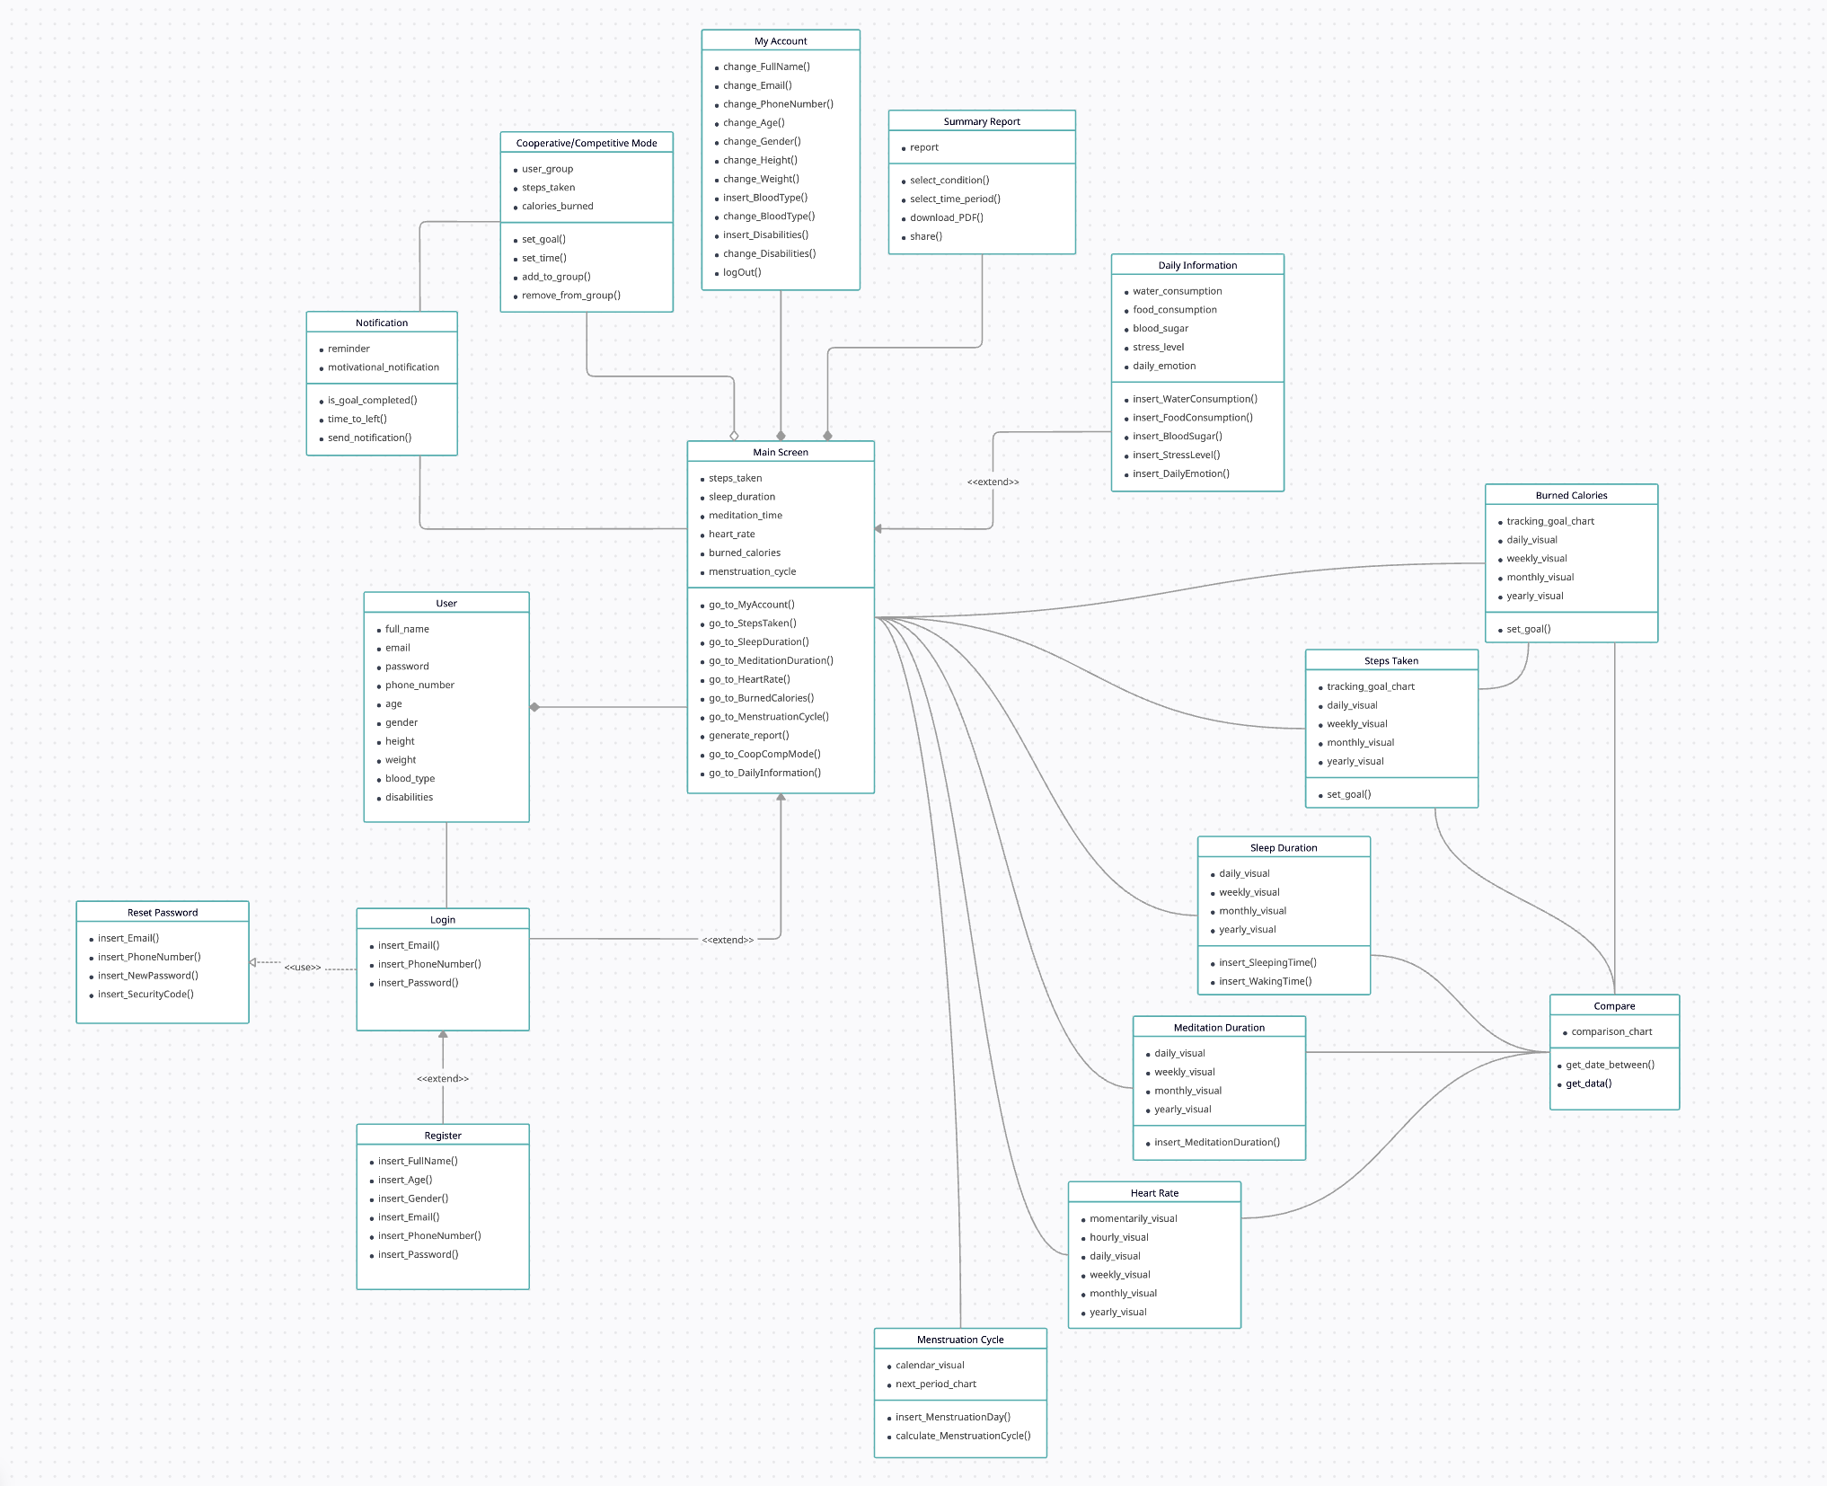

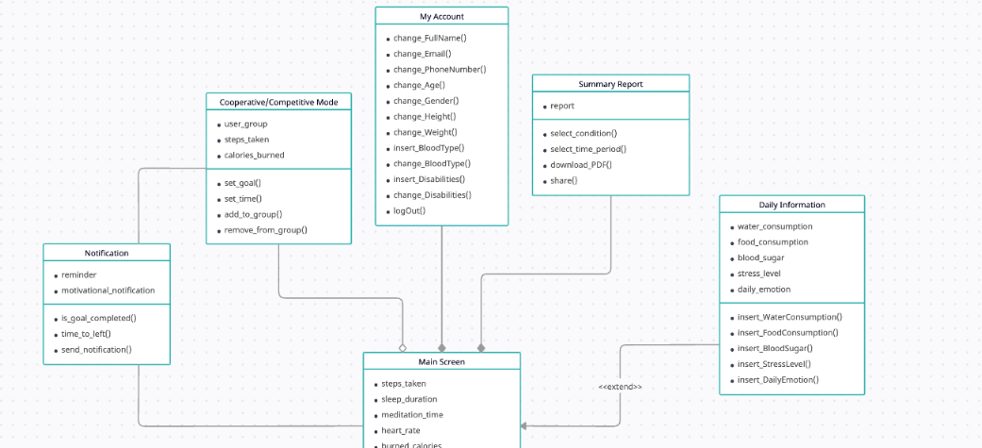

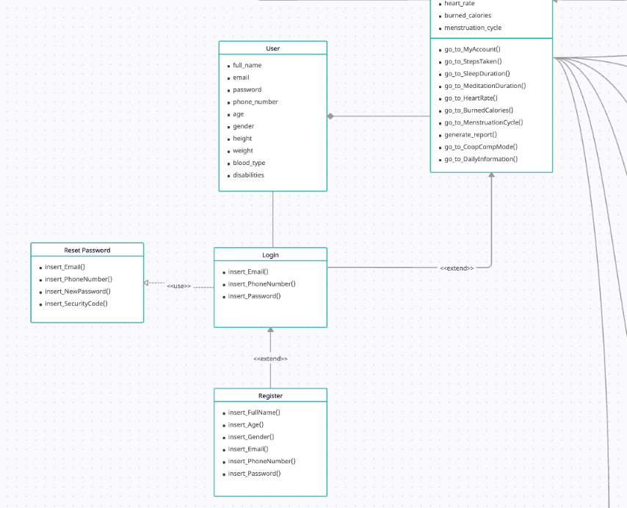

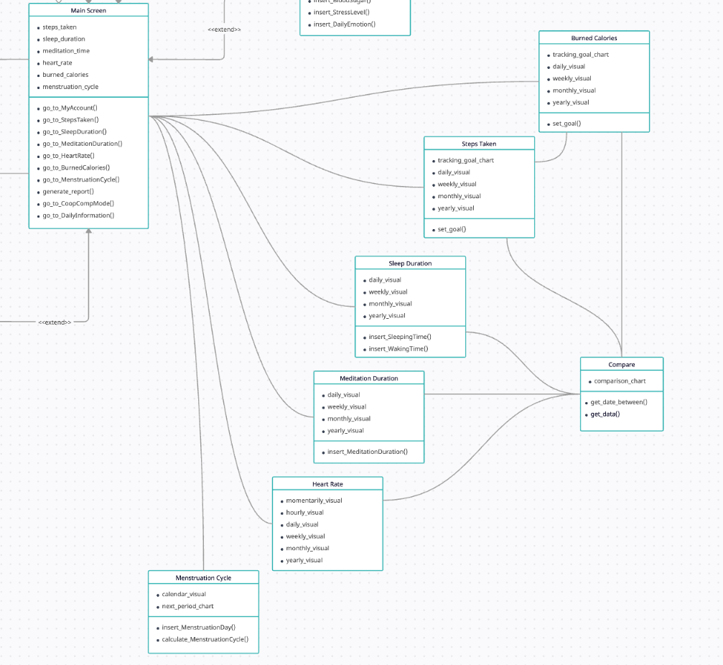

- Sequence Diagram

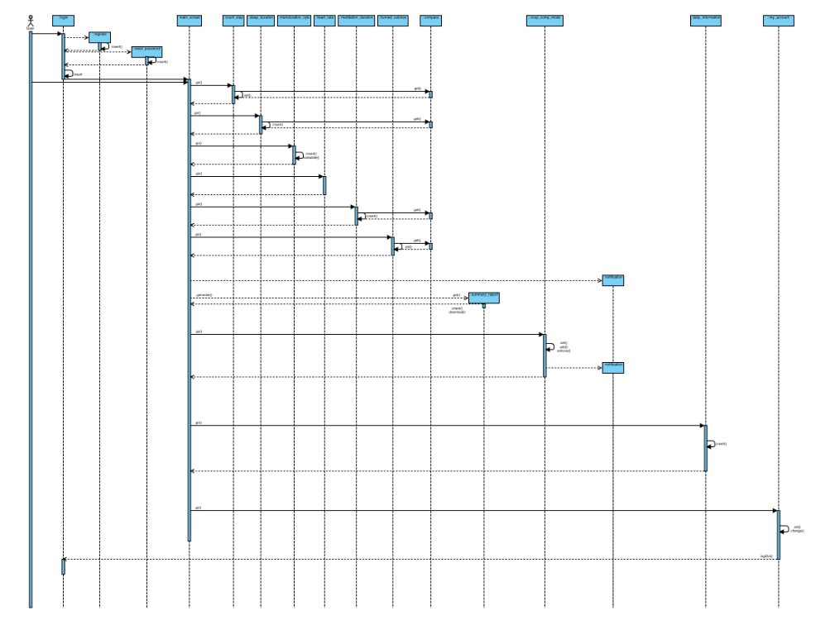

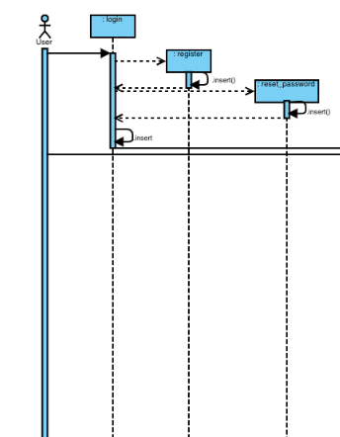

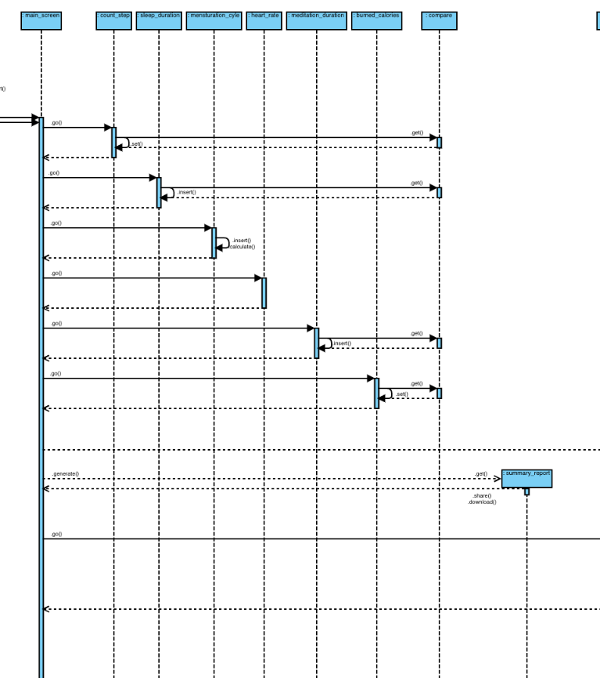

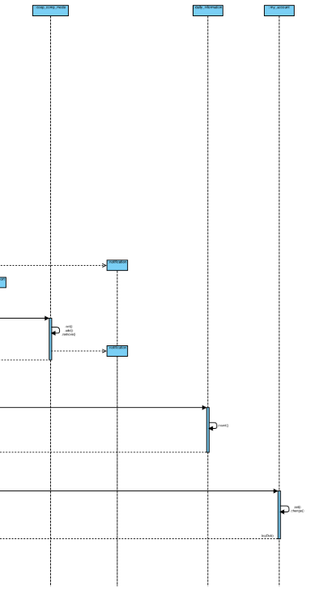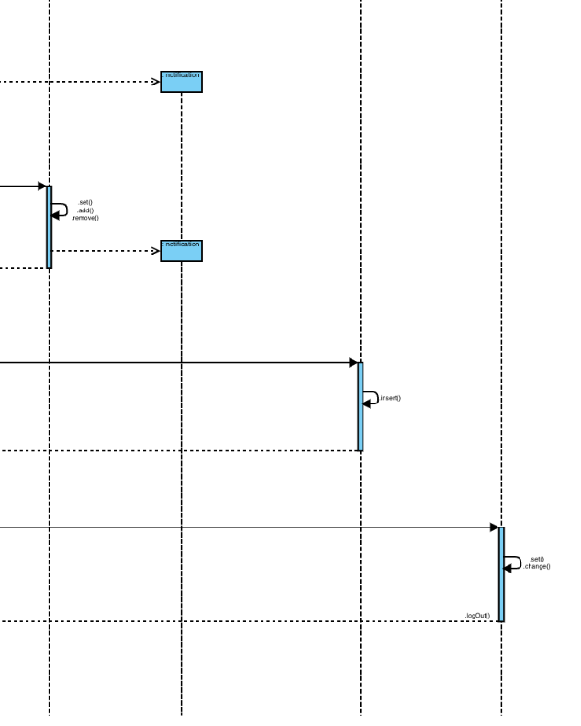

- Activity Diagram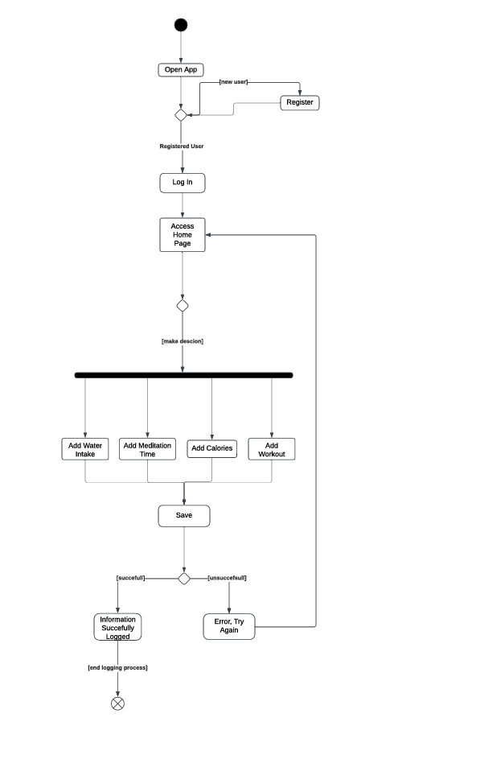
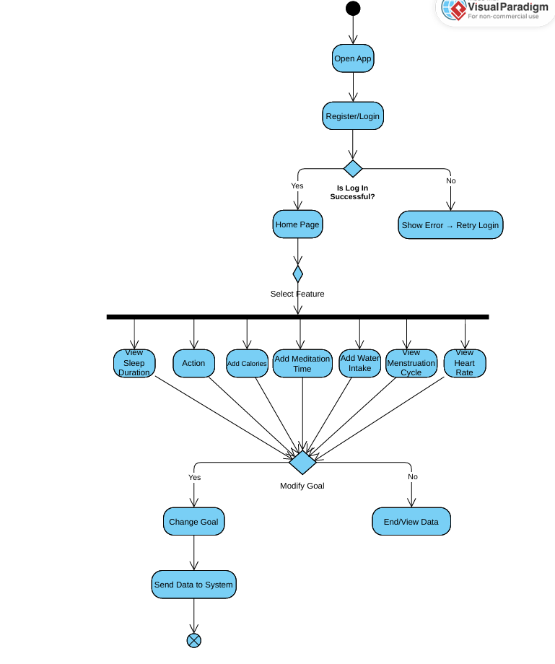

- State Diagram

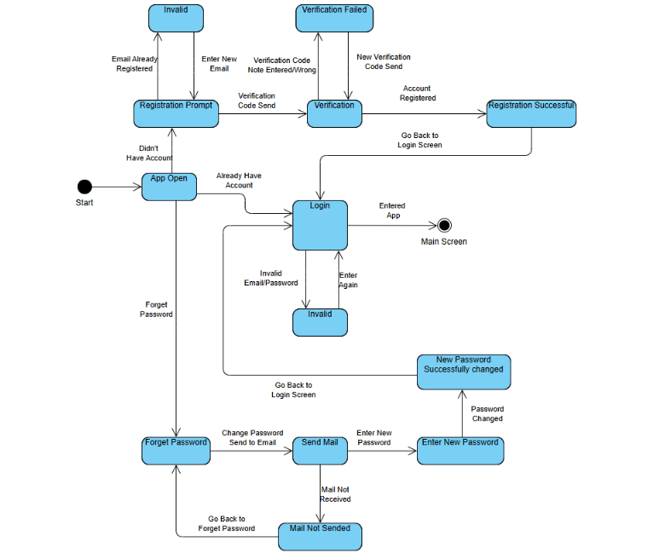

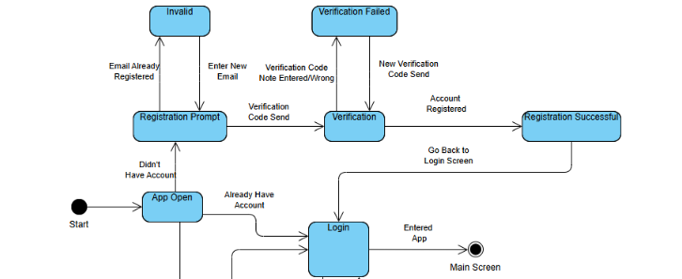

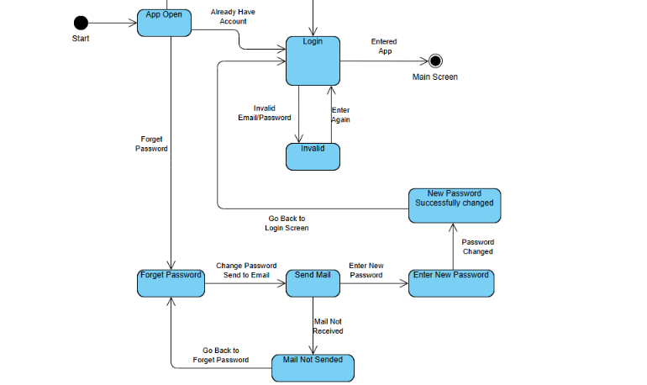
- Project Plan
For the development of the Wellness App, we have chosen Agile Project Management. Agile prioritizes flexibility, collaboration, and continuous feedback, ensuring that the project evolves in alignment with user needs and stakeholder feedback. This methodology will allow us to iteratively deliver high-value features while maintaining a clear vision of the overall project goals.

Development Process

❖ Project Kickoff
➢ Define the project scope and high-level goals. ➢ Establish a Product Backlog with prioritized user stories (e.g., user registration, goal tracking, reporting, notifications).
➢ Assign roles such as:
■ Product Owner: Oversees the backlog and ensures the product aligns with the user's needs.
■ ScrumMaster: Facilitates the Agile process, ensuring the team adheres to Scrum principles.
■ Development Team: Responsible for coding, testing, and delivering features.
❖ Sprint Structure Each sprint will last two weeks, with the following activities:
➢ Sprint Planning:
■ Select user stories from the backlog.
■ Define sprint goals and create tasks for the development team.
➢ Daily Standups:
■ Conduct 15-minute meetings to review progress, discuss roadblocks, and plan the day’s work.
➢ Development and Testing:
■ Develop the features incrementally.
■ Perform unit and integration testing within the sprint.
➢ Sprint Review:
■ Present completed features to stakeholders.
■ Collect feedback to refine future sprints.
➢ Sprint Retrospective:
■ Analyze team performance.
■ Identify areas of improvement.
Design
The design of the Wellness App will focus on the following components:
❖ UI/UXDesign:
➢ Creating intuitive user interfaces (UI) with visually appealing layouts.
➢ Mapping smooth user experiences (UX) to ensure easy navigation and interaction.
❖ SystemDesign:
➢ Developing a modular architecture for front-end, back-end, and database integration.
➢ Ensuring robust and scalable solutions that handle increasing user loads.
❖ Functional Design:
➢ Defining core functionalities such as user registration, goal tracking, notifications, and reporting features.
➢ Establishing logical workflows to guide users efficiently through the app’s capabilities.
❖ Prototyping and Testing:
➢ Using tools like Figma or Adobe XD for wireframing and interactive prototypes.
➢ Conducting usability testing to refine the design based on user feedback.
Roles and Responsibilities
1. Product Owner:
○ Maintains the product backlog and prioritizes features.
○ Communicates with stakeholders to ensure alignment.
2. Scrum Master:
○ Manages the sprint timeline and ensures team productivity.
○ Removes roadblocks and facilitates meetings. 3. Development Team:
○ Implements features as per the sprint plan.
○ Writes code, designs interfaces, and performs testing.
4. Stakeholders:
○ Provide feedback during sprint reviews.
○ Help shape the product based on evolving requirements.

Timeline and Deliverables
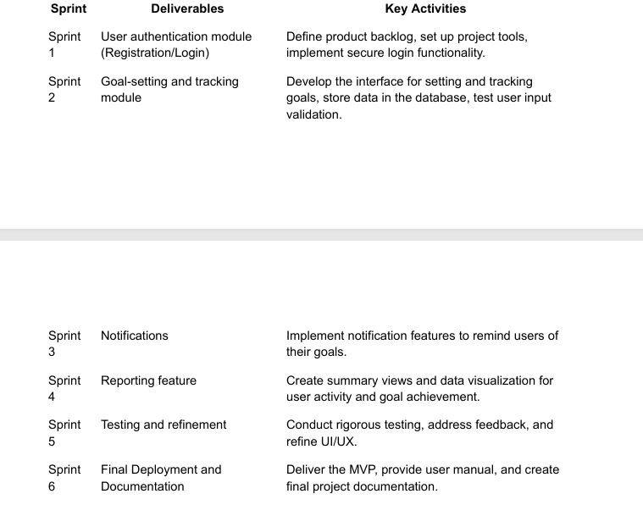

Tools for Agile Project Management
We will use the following tools to enhance collaboration and productivity:
❖ Trello/Jira: For backlog management and tracking sprint progress.
❖ Slack/Teams: For team communication.
❖ GitHub/GitLab: For version control and code management.

Milestones
❖ Milestone 1: Completion of a minimally viable product (after Sprint 4).
➢ Deliver a fully functional Wellness App with core features, ready for stakeholder review and user testing.
❖ Milestone 2: Integration of all features and thorough testing.
➢ Ensure seamless functionality, refined design, and cross-platform compatibility.
❖ Milestone 3: Final product deployment and presentation.
➢ Launch the app with a detailed demonstration for stakeholders and distribute marketing materials for user acquisition.
❖ Milestone 4: Post-deployment evaluation.
➢ Conduct a comprehensive review of the app’s performance, gather feedback, and plan for subsequent iterations.
Risk Management
❖ Agile development requires proactive identification and mitigation of risks. Below are potential risks and strategies:
❖ Unplanned Scope Expansion:
➢ Solution: Maintain a well-defined product backlog and prioritize features in collaboration with stakeholders. Conduct regular reviews to stay aligned with project goals.
❖ Resource Constraints:
➢ Solution: Crosstrain team members to handle multiple tasks and ensure efficient resource utilization.
❖ Technical Challenges:
➢ Solution: Schedule spike solutions during sprints to explore unknowns and reduce uncertainty. Utilize peer code reviews and continuous integration to maintain quality.
❖ Delayed Feedback:
➢ Solution: Schedule regular stakeholder reviews during sprint reviews and leverage collaboration tools to ensure timely input.
❖ Low User Adoption:
➢ Solution: Implement a robust user onboarding process, including tutorials, guides, and in-app walkthroughs. Gather user feedback to address usability issues quickly.
❖ Performance Issues Under Load:
➢ Solution: Conduct thorough performance testing before launch and monitor the app using tools like Firebase, AWS CloudWatch, or Datadog to identify and resolve bottlenecks post-launch.
❖ Negative User Feedback:
➢ Solution: Establish a feedback loop for users through surveys, app reviews, and support channels. Regularly release updates to address concerns and improve features based on feedback.
❖ Security Vulnerabilities:
➢ Solution: Implement security monitoring and regular audits to identify and fix vulnerabilities. Deploy patches quickly for emerging threats.
❖ Feature Creep from Feedback:
➢ Solution: Prioritize post-launch feature requests based on user impact and feasibility. Use a change management process to ensure alignment with the project roadmap.
❖ User Retention Decline:
➢ Solution: Introduce engagement strategies like push notifications, gamification (e.g., rewards), and personalized content to retain users over time.
Post-Deployment Plan
❖ User Training:
➢ Develop a series of short video tutorials and FAQ documentation for onboarding users.
➢ Host a virtual training session for stakeholders and early adopters.
❖ Maintenance and Updates:
➢ Establish a feedback loop with users to gather input for future improvements.
➢ Schedule bi-monthly maintenance sprints to address bugs, performance issues, and feature updates.
❖ Analytics and Monitoring:
➢ Implement tools like Google Analytics or Firebase to monitor user engagement and app performance.
➢ Regularly analyze data to identify trends and areas for improvement.
Impact
The impact of the Wellness App will focus on:
❖ Users: Enhancing user well-being by providing tools for goal setting, tracking, and achieving personal wellness objectives.
❖ Stakeholders: Delivering measurable improvements in engagement, user retention, and satisfaction through intuitive features.
❖ Business Goals: Supporting organizational objectives by promoting user adoption and ensuring long-term value.
❖ Technical Performance: Optimizing app performance and scalability to provide a seamless user experience with minimal downtime.
Budget
❖ Development (40%): Since the app relies heavily on core features like goal tracking and reporting, development takes the largest portion of the budget.
❖ UI/UXDesign (15%): An intuitive, user-friendly interface is critical for user adoption and satisfaction.
❖ Testing (10%): Ensures a smooth, bug-free experience for users.
❖ Marketing (10%): Essential for user acquisition, ensuring the app reaches its target audience.

8) Architecture & Design
1. Front-End: User Interface
- Technology: React Native (for cross-platform mobile app development).
- Features:
  - Intuitive user interface for setting, tracking, and visualizing progress on wellness goals.
  - Secure authentication screens for user registration and login.
  - Personalized dashboards displaying daily activities, progress summaries, and relevant insights.
  - Real-time notifications and reminders to enhance user engagement and motivation.
2. Back-End: Business Logic & API Layer
- Technology: Node.js with Express (or Python with Django/Flask) for API development.
- Features:
  - User Management: Secure user registration, login, profile management, and authorization.
  - Goal Management: Functionality to create, update, delete, and manage user-defined wellness goals.
  - Data Tracking: Secure storage and retrieval of daily activity logs, including steps, sleep duration, meditation time, heart rate, and other relevant metrics.
  - Business Logic: Implementation of core application logic, including calculations, data processing, and validation.
  - Reporting: Generation of summarized historical data reports (weekly, monthly, custom ranges) for user review and analysis.
  - Notification Triggers: Logic for triggering push notifications and reminders based on user activity, goal progress, and predefined schedules.
3. Database: Data Storage
- Database System:
  - PostgreSQL: For structured data, including user profiles, goals, metrics, and relational data.
  - MongoDB: For flexible storage of unstructured or semi-structured data, such as detailed activity logs, event data, and notification history.
- Features:
  - Efficient storage and retrieval of user data.
  - Data integrity and consistency through relational database features.
  - Scalable storage solutions to accommodate growing data volumes.
  - Indexing and optimization for fast query performance.
4. Authentication & Security
- Authentication System: OAuth 2.0 for secure authorization and JWT (JSON Web Token) for stateless session management.
- Security Measures:
  - HTTPS for secure communication between client and server.
  - Robust input validation and sanitization to prevent common web vulnerabilities like SQL injection and cross-site scripting (XSS).
  - Role-Based Access Control (RBAC) to manage user permissions and restrict access to sensitive data and functionalities.
  - Secure password hashing using bcrypt or similar algorithms.
5. Notifications System
- Push Notifications: Firebase Cloud Messaging (FCM) for Android and Apple Push Notification Service (APNs) for iOS to deliver timely notifications and reminders.
- Notification Scheduling: Ability to schedule notifications based on user activity, goal progress, and custom preferences.
6. Reporting and Analytics
- Features:
  - Generation of detailed progress reports with aggregated data from the database.
  - Data visualization through interactive charts and graphs using libraries like Chart.js or D3.js (if needed on the web dashboard).
  - Options for exporting reports in various formats (e.g., PDF, CSV).
- Implementation: The back-end processes and aggregates user data, providing it through APIs to the front-end for display and visualization.
7. Cloud Infrastructure
- Cloud Provider: AWS, Azure, or Google Cloud Platform (GCP) for hosting and managing the application infrastructure.
- Services:
  - API Gateway for managing and securing API endpoints.
  - Serverless Functions (e.g., AWS Lambda, Azure Functions, Google Cloud Functions) for executing server-side logic in a scalable and cost-effective manner.
  - Managed Databases (e.g., Amazon RDS for PostgreSQL, MongoDB Atlas) for simplified database management.
  - Object Storage (e.g., Amazon S3, Azure Blob Storage, Google Cloud Storage) for storing reports, user uploads, and other static assets.
8. Scalability and Performance
- Microservices Architecture: Decoupling application functionalities into independent microservices (e.g., authentication, user management, data processing, notifications) for improved scalability and maintainability.
- Load Balancing: Distributing traffic across multiple server instances to ensure high availability and responsiveness.
- Caching: Implementing caching mechanisms (e.g., Redis, Memcached) to store frequently accessed data and reduce database load.
- Horizontal Scaling: Ability to easily scale the application by adding more server instances as the user base grows.
9. Monitoring and Maintenance
- Monitoring Tools: Integration with monitoring tools (e.g., New Relic, Datadog, Prometheus) for real-time performance monitoring, alerting, and issue tracking.
- Logging: Centralized logging using tools like ELK stack (Elasticsearch, Logstash, Kibana) or cloud-native logging services for efficient log management and analysis.

9) Testing
Testing is a crucial phase in the software development lifecycle, designed to ensure that the Wellness App meets all functional and non-functional requirements while providing a seamless and reliable user experience. By systematically evaluating the app’s performance under various conditions, the testing phase enhances confidence in the software's ability to function as intended and meet user expectations. This section outlines the testing strategies, scenarios, tools, and metrics used to validate the Wellness App.
9.1 Testing Strategies
To ensure the app’s quality, the following testing strategies will be implemented:
1. Unit Testing:
◦ Focuses on verifying individual components of the app, such as user authentication, goal setting, and notifications.
◦ Each module will be tested in isolation to ensure it performs as expected.
◦ Frameworks like JUnit and TestNG will be used to automate these tests and provide comprehensive code coverage.
2. Integration Testing:
◦ Validates the interaction between the app’s modules to ensure smooth data flow and seamless functionality.
◦ For instance, integration testing will verify that goal updates are accurately reflected in the reporting and notification modules.
◦ Simulations of real-world interactions will identify potential integration issues.
3. System Testing:
◦ Evaluates the complete and integrated application against the specified requirements.
◦ This end-to-end testing ensures workflows such as registering, tracking progress, and generating reports work harmoniously.
- User Acceptance Testing (UAT):
◦ Conducted with real users to validate that the app meets their expectations in terms of usability, functionality, and overall satisfaction.
◦ Feedback gathered during UAT will guide final refinements before deployment.
- Regression Testing:
◦ Ensures that updates, bug fixes, or new features do not negatively impact the app’s existing functionalities.
◦ Periodic regression tests will maintain app stability, with automation tools handling repetitive tests.
- Performance Testing:
◦ Assesses the app’s responsiveness, stability, and scalability under various conditions, including peak usage scenarios.
◦ Metrics such as response time, throughput, and memory usage will be evaluated to ensure optimal performance.
7. Security Testing:
◦ Identifies vulnerabilities and ensures the app adheres to security best practices.
◦ Testing will include secure authentication, data encryption, and protection against common threats such as SQL injection and cross-site scripting (XSS).
9.2 Test Scenarios
The testing process will involve a variety of scenarios to validate both functional and non-functional aspects of the app.
1. Functional Test Scenarios:
◦ User Registration and Login:
▪ Verify that users can register with valid credentials and receive appropriate feedback for invalid inputs.
▪ Test the password recovery feature to ensure secure access recovery.
◦ Goal Management:
▪ Validate that users can set, update, and save personalized goals (e.g., steps, sleep duration).
▪ Confirm that goals persist and display correctly across sessions.
◦ Daily Activity Tracking:
▪ Ensure users can input data (e.g., steps taken, hours of sleep) without errors.
▪ Validate that the app updates progress toward user goals accurately.
◦ Notifications:
▪ Test notifications for timing, accuracy, and clarity (e.g., motivating users to reach their goals).
▪ Verify that users can enable or disable notifications.
◦ Progress Reporting:
▪ Ensure users can view accurate summaries of historical data (e.g., daily, weekly, monthly).
▪ Validate the formatting of exported reports, such as PDFs.
2. Non-Functional Test Scenarios:
◦ Performance Testing:
▪ Measure response times for key operations, such as loading reports and sending notifications.
▪ Simulate heavy loads to test app behavior during peak usage.
◦ Usability Testing:
▪ Evaluate the app’s design for ease of navigation and clarity.
▪ Conduct user testing to identify potential barriers or frustrations.
◦ Compatibility Testing:
▪ Ensure smooth functionality across devices, operating systems (iOS, Android), and screen sizes.
◦ Reliability Testing:
▪ Simulate prolonged usage to identify potential crashes or memory leaks.
▪ Test the app under low network conditions to ensure consistent performance.
◦ Security Testing:
▪ Validate encryption protocols and secure storage practices for sensitive user data.
▪ Test for vulnerabilities to prevent unauthorized access or data breaches.
3. Integration Test Scenarios:
◦ Verify that updates to goals are reflected in notifications and reporting modules.
◦ Ensure smooth data flow between user input, tracking, and reporting components.
4. System Test Scenarios:
◦ Test complete workflows from user registration to goal tracking and reporting.
◦ Validate interactions between all modules for seamless functionality.
5. User Acceptance Test Scenarios:
◦ Gather feedback from real users on the app’s usability, functionality, and feature alignment.
◦ Address any gaps identified during UAT to enhance the overall user experience.
9.3 Tools and Frameworks
The following tools and frameworks will support the testing process:
• Unit Testing: JUnit, TestNG
• Integration Testing: Postman, REST Assured
• Performance Testing: Apache JMeter, LoadRunner
• Security Testing: OWASP ZAP, Burp Suite
• Usability Testing: UserTesting.com or manual observations with diverse user groups Automation tools will be employed to improve efficiency and ensure thorough coverage during regression and repetitive tests.
9.4 Test Environment
To ensure accurate and reliable testing results, the test environment will simulate real-world conditions. This includes:
• Testing on a wide range of devices and operating systems (iOS, Android) to ensure compatibility.
• Simulating varying network speeds and connectivity issues to test app performance under different conditions.
• Establishing a secure testing environment to handle sensitive user data, ensuring compliance with security standards.
9.5 Test Metrics
Measuring the effectiveness of the testing process will rely on key metrics, including:
• Defect Density: Tracks the number of defects identified per module to pinpoint areas needing improvement.
• Test Coverage: Measures the percentage of code and functionalities covered during the testing process.
• Response Time: Evaluates the app’s performance for critical operations, such as updating goals or generating reports.
• User Feedback: Collects insights from usability testing to evaluate satisfaction and identify improvement opportunities

